TechLawForum@NALSAR
Tech Weekend

Saturday, March 7th
Lecture 1: Amlan Mohanty, Privacy and the Internet of Things. [12:00 PM – 01:00 PM]
Lecture 2: Geetha Hariharan, Perspectives on Internet Governance. [04:00 PM – 05:00 PM]
Screening: CitizenFour. [08:30 PM – 10:30 PM]
Sunday, March 8th
Lecture 1: Nirupama Jayasimha, The Ethics and Legalities of Webscraping. [11:00 AM – 12:00PM]
Lecture 2: Swaraj Paul Barooah, The Economics of Information. [01:30 PM – 02:00 PM]
Screening: Black Mirror Christmas Special: White Christmas. [02:30 PM – 03:30 PM]
Chinmayi Arun and Arun Mohan Sukumar’s lectures will take place on 10/11th March.
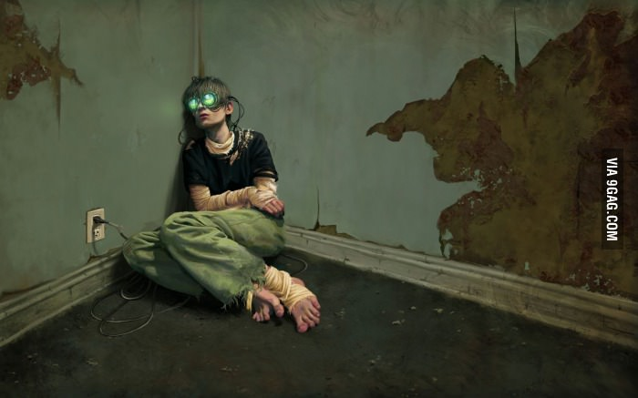
Tech & Art Exhibition: The Potentials of Virtual Reality
The TechLawForum@NALSAR is organising a Virtual Reality exhibition for people attending the Tech Weekend, showcasing the potential of virtual reality not just in specific areas but as an entirely new medium of content-consumption and communication altogether. The showcases includes a Virtual Reality tour of a refugee camp in Syria, a CGI-created VR movie, a VR horror movie, putting the viewer on Mars, taking a virtual tour of the Earth on Google Earth, a Paul McCartney concert and many other mindboggling exhibitions. These are the experiences that will leave you wondering how long it will take till the above image, reminiscent of the ‘Better Than Life’ VR game/drug in the Red Dwarf novel/TV series, becomes true – how long till the lines between Virtual Reality and Reality blur so much, that they become illegible.

For the people who wish to use the VR headsets, please note the following:
- The exhibitions will be conducted after every lecture, and attendance of the lectures is mandatory to participate in the same. Only the attendees of each lecture will be allowed to participate in the VR exhibit that follows.
- You would need an Android smartphone with screen size between 4 to 6 inches.
- The following applications should be installed on your smartphone:
  - Cardboard (by Google).
  - VRSE – a Sundance Selection.
  - Orbulus.
  - ‘Sisters’ and/or ‘Chair in a Room’.
- There are different, less epic apps available for Apple devices as well. Anyone with an Apple device who wants to use the VR headsets should get in touch with Kartik Chawla.
Note: Anyone who wishes to volunteer for the event can get in touch with Kartik Chawla or Balaji Subramanian personally.

